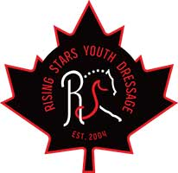
Sportsmanship Nomination Award

This award will be presented to the rider or groom (age 18 and under) who has shown outstanding sportsmanship conduct within our sport. The recipient is nominated by RS competitors at ODF2022 and is chosen by the RS leaders based on the description below.

Please provide a brief description of why your nomination is a deserving recipient of this award. The RS committee will review the submissions and the award will be presented at the end of the equitation Ride-off.

Submissions must be delivered to the RS tent by Saturday at 3 p.m.

I ______________________(Your name), nominate competitor____________________show number_______.

Signed__________________Print___________________Show Number________
I am not a relative of the above person.

